DAD 220 Module Three Major Activity Template

Overview

Complete these steps as you work through the directions for this activity. Replace the bracketed text with a screenshot and brief explanation where indicated. Each screenshot and its explanation should be sized to approximately one-quarter of the page with the description written below the screenshot. Review the Template Screenshot Example linked in the guidelines and rubric for this assignment to see how screenshots for your assignment should look.

Create a Database

- In your online integrated development environment (Codio), create a database schema called Quantigration RMA that can hold tables.
  - List the database name on the screen.
  - Provide the SQL commands you ran to successfully complete this step.

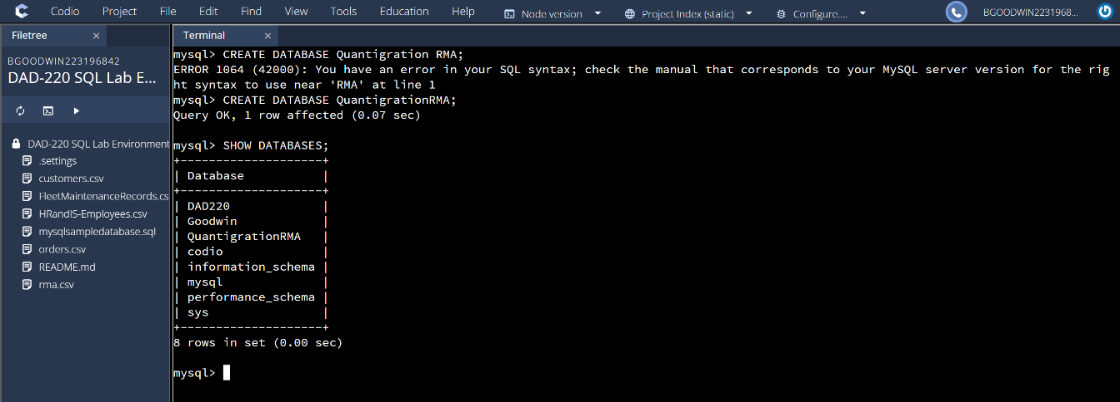

- Connect to the Quantigration RMA schema. Create the following tables with the appropriate attributes and keys in the Quantigration RMA database using the Quantigration RMA Entity Relationship Diagram (ERD) as a reference:

  - A table named Customers to store customer information with a primary key of Customer ID
    - Provide the SQL commands you ran against MySQL to complete this successfully in your answer:

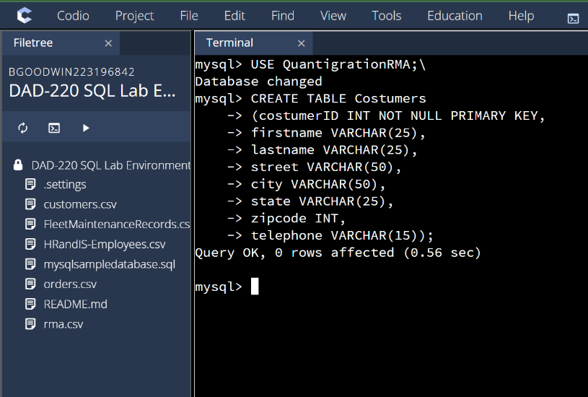
Went into the database and created this table given the parameters set by the entity relationship diagram. With the appropriate parameter for each column as well as setting up the primary key so it can eventually connect to another table and also means it cannot have NULL values.

  - A table named Orders to store order information with a primary key of Order ID and foreign key of Customer ID
    - Provide the SQL commands you ran against MySQL to successfully complete this step.

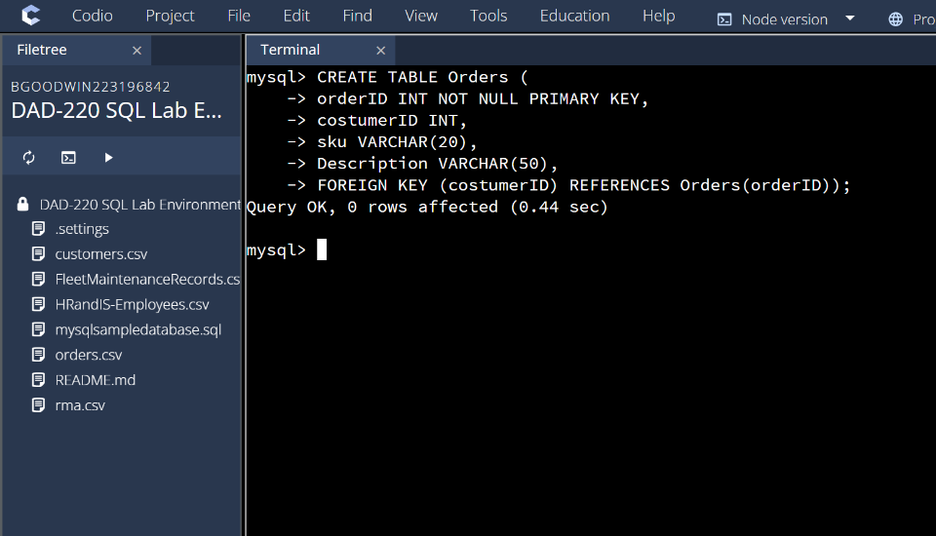

Like the first table I set up the information according to the diagram using the commands, with the exception being that I added a foreign key which connects one table to another with a primary key which is costumerID and references also sets up orderID to act as a primary key as well to connect. This table is connected to the costumers table and the RMA table.

  - A table named RMA to store RMA information with a primary key of RMA ID and foreign key of Order ID
    - Provide the SQL commands you ran against MySQL to successfully complete this step.

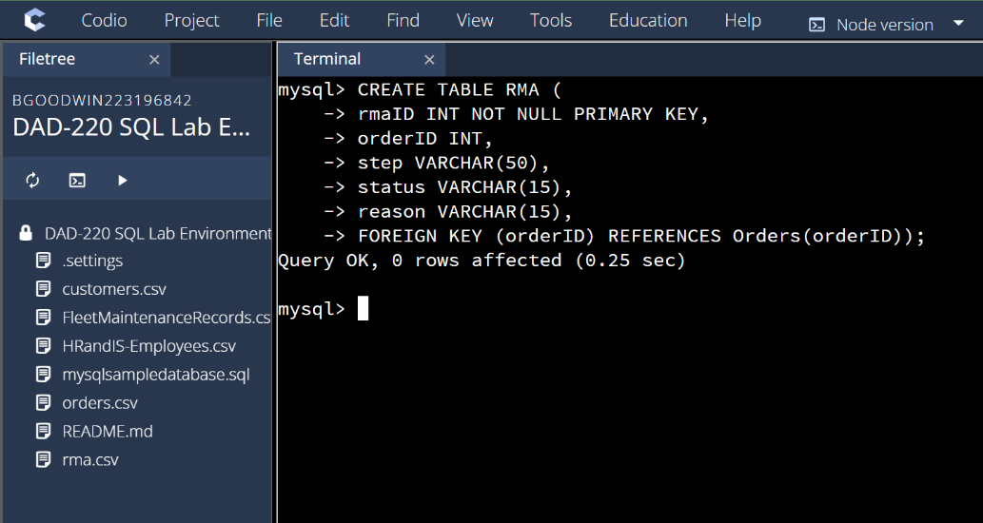

This table was created the same as the others with the parameters from the diagram and is only connected to the Orders table through the keys.

- Manually add 10 records into the Customers table. For now, you can make up data. In a later assignment, you will use the CSV files provided to fill in all three tables.

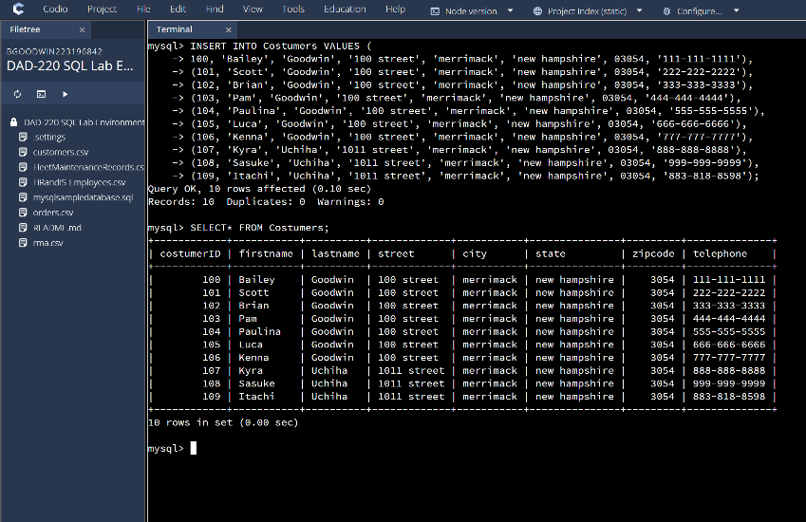

The information was manually entered in accordance with the columns that needed to be filled with information for 10 costumers. All columns need the corresponding information and to have the information match it’s parameters.

- You’ve been asked to establish a database view called Collaborators based on the Customers table. Create the Collaborators View from the existing Customers table by using the SQL command below to say "Collaborators". The view should show all instances of "Customer" renamed as "Collaborator". Execute the following statements and provide one or more supporting screenshots showing the database view.
  - The following command is partially complete. Fill in the missing information in the brackets to complete then command and run it correctly:

CREATE VIEW Collaborator AS
SELECT CustomerID AS CollaboratorID
[Enter in the correct column names from the Customer table that you want to change in the Collaborator table]
FROM Customers;

  - DESCRIBE Collaborator;
  - SELECT * FROM Collaborator LIMIT 5;

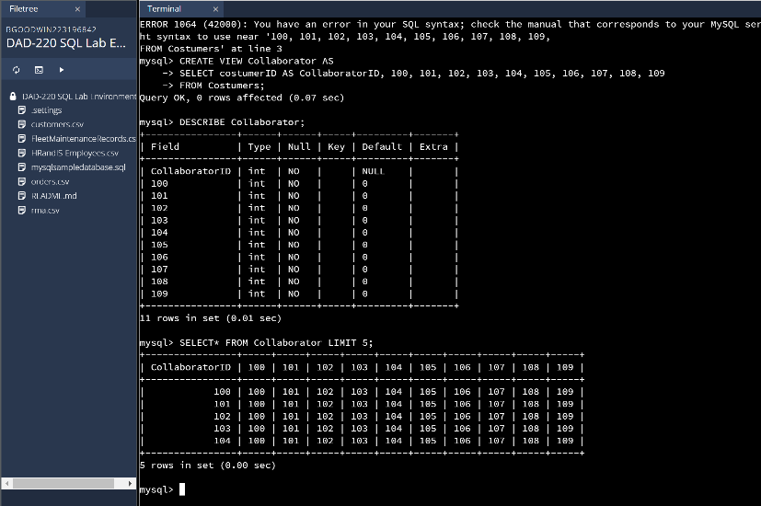

The create view options created a new view of the information called collaborator which was filled with the costumerID numbers from the costumer table. The describe command shows how the information that is in collaborator as well as the type of information it is. The Limit option compared 5 customer ID’s against the 10 IDs that were entered.

